Press release: 2 May 2016

Pune, 2 May 2016

Pune-based Venture Center wins National Award for Technology Business Incubation

Venture Center (also called the Entrepreneurship Development Center), the technology business incubator hosted by the CSIR-National Chemical Laboratory, Pune, has bagged the National Award for Technology Business Incubation for this year. The National Science and Technology Entrepreneurship Development Board, Department of Science and Technology, Government of India announced this today in New Delhi. Venture Center shall receive the award from the Honorable President of India, ShriPranab Mukherjee, on 11 May 2016 at VigyanBhawan, Delhi on the occasion of National Technology Day.

This award recognizes the contribution of Venture Center to promoting and nurturing scientific entrepreneurship in the Country and more specifically in the Pune region. Venture Center is today home to 35+ scientific ventures. Most of these are inventive enterprises driven by scientists and engineers. Women entrepreneurs have founded more than 30% of the startups incubated at Venture Center. Entrepreneurs associated with Venture Center have won several national and international competitive awards and funds. Venture Center also has the distinction of helping create several spin-off companies from publicly funded research labs in India.

Notes to the Editor

Photos:

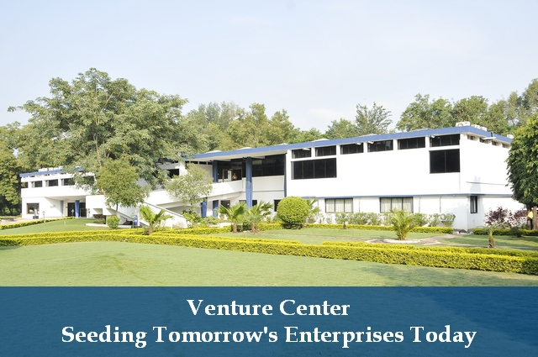
http://venturecenter.co.in/socialenterprises/images/VC-Main.jpg

About Venture Center:

Venture Center is a technology business incubator specializing in technology startups offering products and services exploiting scientific expertise in the areas of materials, chemicals and biological sciences & engineering. Venture Center is the trademark of Entrepreneurship Development Center, a not-for-profit company hosted by the CSIR-National Chemical Laboratory, Pune, India.Venture Center is India's largest science business incubator hosting 35+ resident startups.Venture Center strives to nucleate and nurture technology and knowledge-based enterprises. The Venture Center aims to empower and enable scientists and engineers in pursuing technology, innovation and entrepreneurship objectives. More information: http://venturecenter.co.in

About CSIR-National Chemical Laboratory, Pune:

National Chemical Laboratory (CSIR-NCL), Pune, established in 1950, is a constituent laboratory of Council of Scientific and Industrial Research (CSIR). CSIR-NCL is a science and knowledge based research, development and consulting organization. It is internationally known for its excellence in scientific research in chemistry and chemical engineering as well as for its outstanding track record of industrial research involving partnerships with industry from concept to commercialization. CSIR-NCL is the largest patent filing non-profit organization in India. CSIR-NCL produces one of the largest numbers of publications and PhD students in the chemical sciences in India. More information: http://www.ncl-india.org

